**NAMA: ANDI DWI SAPUTRO**

**Hackerrank username: andiads06 (DAY 2)**

1. **Soal Medium**
2. **Java Priority Queue**

**Link:** https://www.hackerrank.com/challenges/java-priority-queue/problem

Accepted Answer:

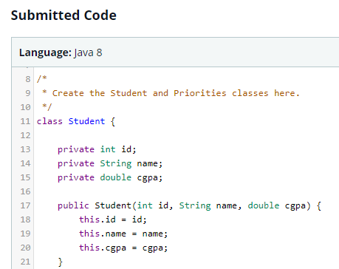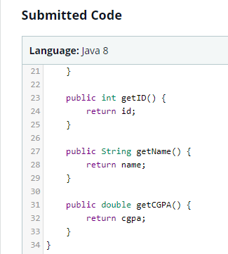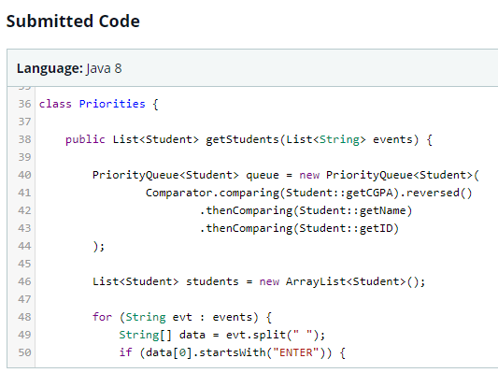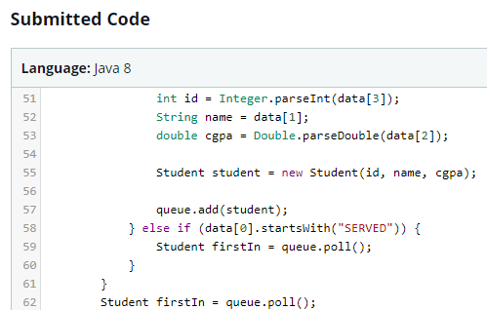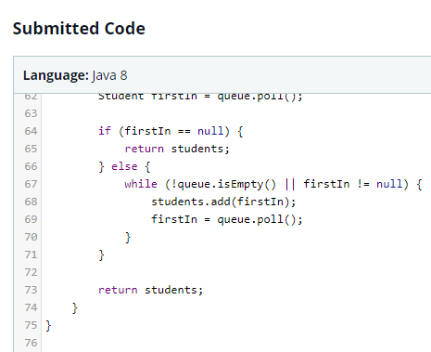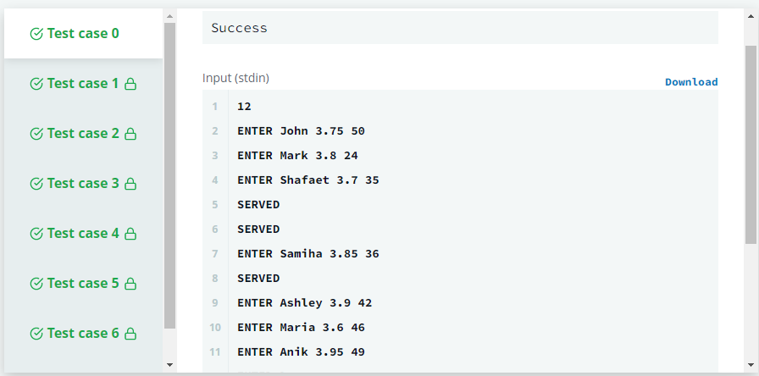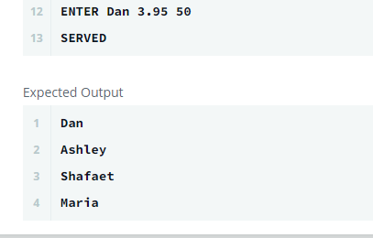

1. **Soal Easy**
2. **Java Static Initializer Block**

**Link:** https://www.hackerrank.com/challenges/java-static-initializer-block/problem

Q: If both values are greater than zero, then the main method must output the area of the parallelogram. Otherwise, print "java.lang.Exception: Breadth and height must be positive" without quotes.

Accepted Answer:

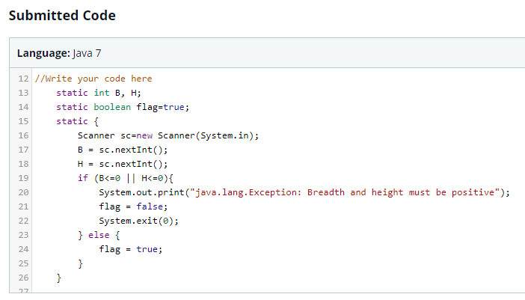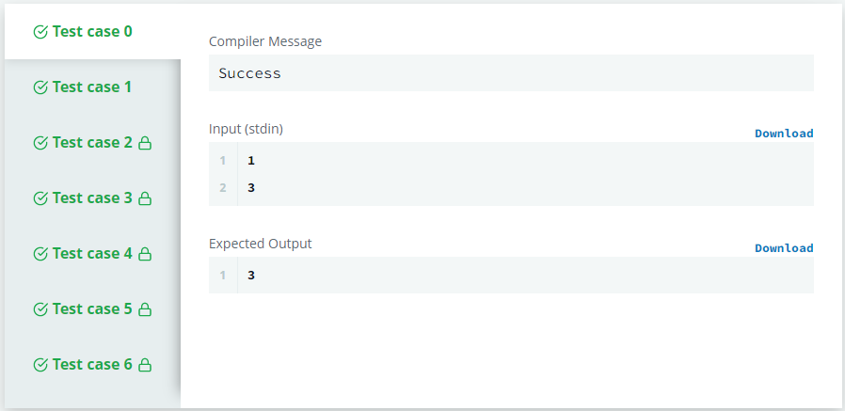

1. **Java Int to String**

**Link:** <https://www.hackerrank.com/challenges/java-int-to-string/problem>

Q: You are given an integer n, you have to convert it into a string.

Please complete the partially completed code in the editor. If your code successfully converts  n into a string s the code will print "*Good job*". Otherwise it will print "*Wrong answer*".

Accepted Answer:

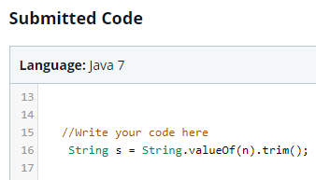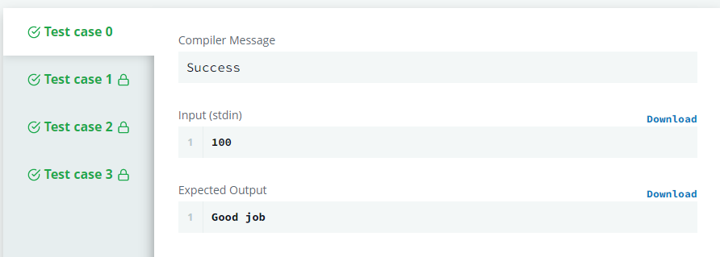

1. **Java Date and Time**

**Link:** <https://www.hackerrank.com/challenges/java-date-and-time/problem>

Q: You are given a date. You just need to write the method, getDay() which returns the day on that date. To simplify your task, we have provided a portion of the code in the editor.

Accepted Answer:

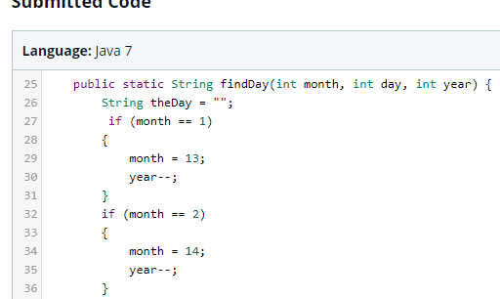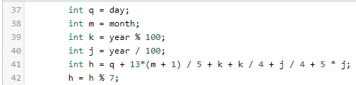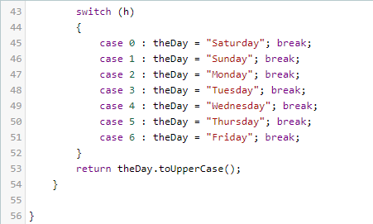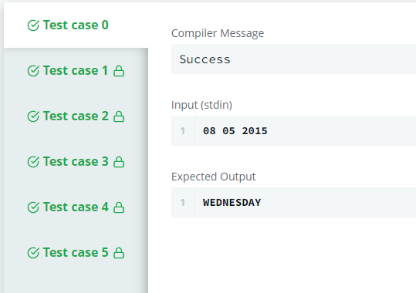

1. **Java Currency Formatter**

**Link:** <https://www.hackerrank.com/challenges/java-currency-formatter/>

Q: Given a [double-precision](https://en.wikipedia.org/wiki/Double-precision_floating-point_format) number, payment, denoting an amount of money, use the [NumberFormat](https://docs.oracle.com/javase/8/docs/api/java/text/NumberFormat.html) class' [getCurrencyInstance](https://docs.oracle.com/javase/8/docs/api/java/text/NumberFormat.html#getCurrencyInstance-java.util.Locale-) method to convert payment into the US, Indian, Chinese, and French currency formats.

Accepted Answer:

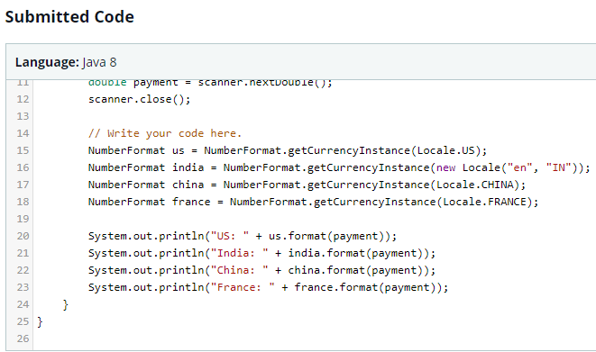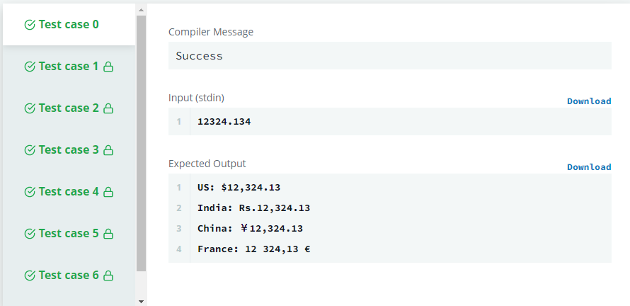

1. **Java Valid Username Checker**

**Link:** <https://www.hackerrank.com/challenges/valid-username-checker/>problem

Q:

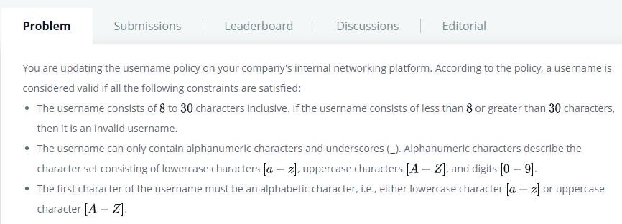

Accepted Answer:

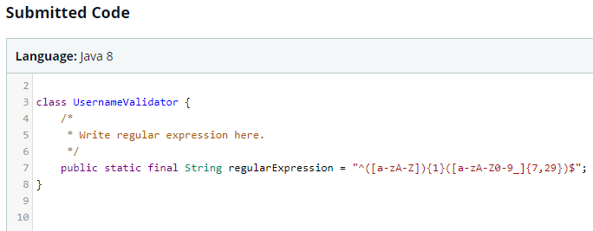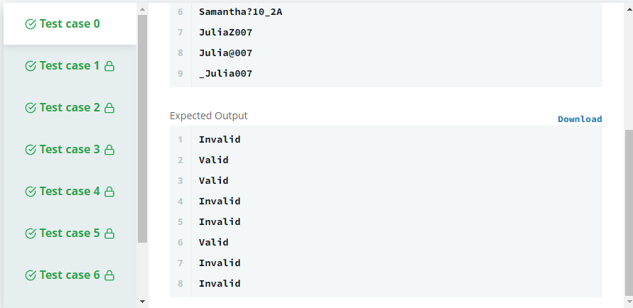

1. **Java Loops I**

**Link:** <https://www.hackerrank.com/challenges/java-loops-i/problem>

Q:



**Accepted Answer:**

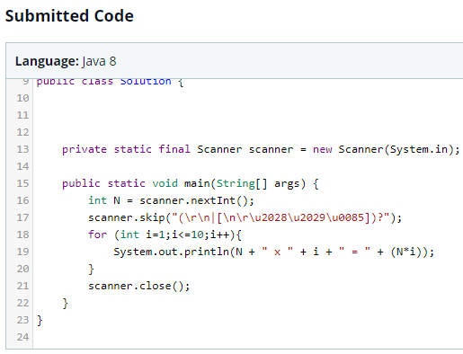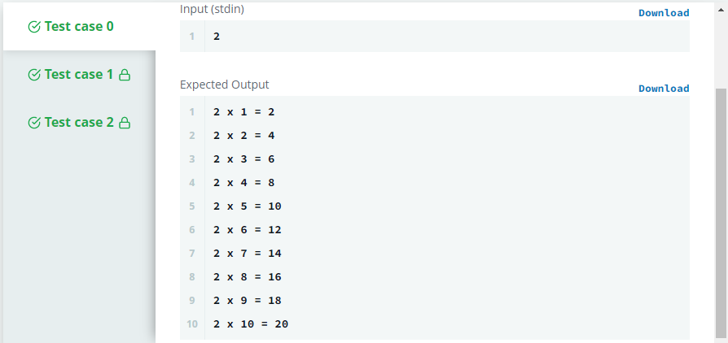

1. **Java Loops II**

**Link:** <https://www.hackerrank.com/challenges/java-loops/problem>

Accepted Answer:

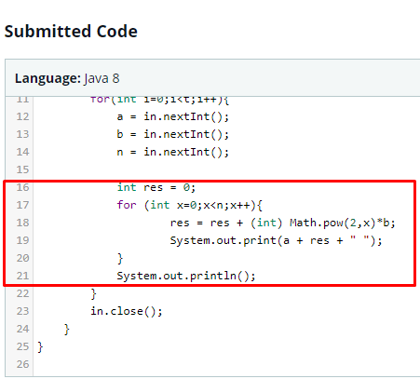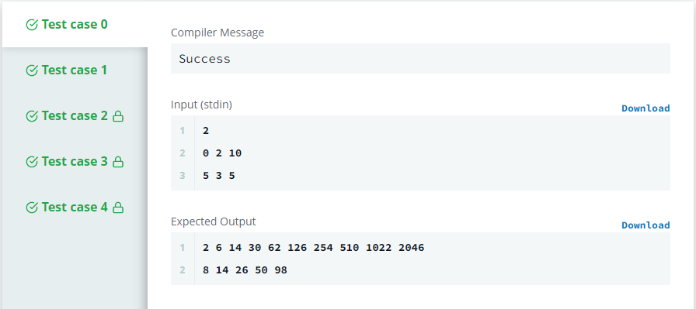

1. **Java Data Types**

**Link:** <https://www.hackerrank.com/challenges/java-datatypes/problem>

**Accepted Answer:**

